Town Manager’s Update
August 8, 2016

The following items are of note since the last council meeting:
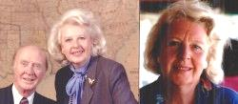
Stella B. Patten
Stella Patten passed away in Topsham on July 11, 2016. Stella served on the town council from 1975 to 1978. She was the first woman elected to the town council. The time she served was very busy for the town with closure of the open burning dump, a new alliance with what has become ecomaine, decisions to convert Fort Williams into an area that is predominantly a park, with the development of a large sewer project in the northern area of town and an agreement with South Portland to treat sewerage from the northern part of town. Stella was a strong advocate of citizen communication and published her own newsletter that was quite controversial at the time. Stella had also taught in both South Portland and Cape Elizabeth schools. I was happy to have been able to see her about a year ago when she was reminiscing about her time in Cape Elizabeth.
Beach to Beacon
The 19th annual Beach to Beacon Road race was this past Saturday with 6338 finishers including 639 registering with Cape Elizabeth addresses. Thank you to our municipal departments, the school department and all the volunteers who supported the event. We also could not have this event in Cape Elizabeth without all of the support we receive from neighboring communities. 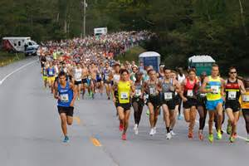

Road and Sidewalk Work
This past month Spurwink Avenue near the South Portland line and Wells Road were paved. A sidewalk was also substantially reconstructed on a portion of Oakhurst. Work will continue on another section of the sidewalk on Oakhurst Road.
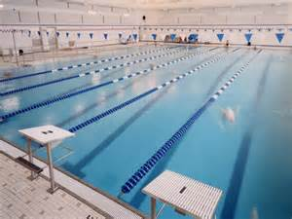
Pool Closed
The Donald Richards Community Pool closed on August 5th and is anticipated to be closed for 6 to 7 weeks while the pool filtering system is replaced and other repairs and updates are undertaken.
The work is being funded by a bond approved by the town council and work on doorway and shower facilities with an appropriation also approved by the town council.

Winter Moth Forum
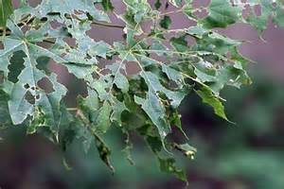
The Cape Elizabeth Garden Club sponsored a forum last week at the Thomas Memorial Library on winter moths. Winter moths have defoliated many crabapple, red maple and oak trees in Cape Elizabeth. There is also an impact of blueberry shrubs. According to Charlene Donahue who is the state entomologist, three to four years of defoliation will result in tree mortality. She and Town Tree Warden Mike Duddy told the over 60 citizens who were present that broad based use of pesticides to combat the infestation is not possible as the secondary impacts would be significant. Some limited use of pesticides can help individual trees. Banding trees is also not practicable as the caterpillars would simply cover the bands quickly and continue up the trees. A placement of flies that attack the caterpillars is helpful but the supply of the flies is not significant enough to control the damage. This year this was less defoliation than a year ago due to the cold spring but the winter moths have spread over more of the community. The bottom line appears that we will have many trees needing to be removed in the next few years. In places like Fort Williams, outer Fowler Road, Charles Jordan Road, Shore Road, Mitchell Road and Old Ocean House Road, the appearance of the roads will change significantly as the tree canopy disappears. The town has already changed what trees in recommends to be planted in new subdivisions. The council may also wish to consider a larger budget for tree planting.

Upcoming Forums and Events from Town Website

Committee to hold public forum on amphitheater seating proposal for Fort Williams Park
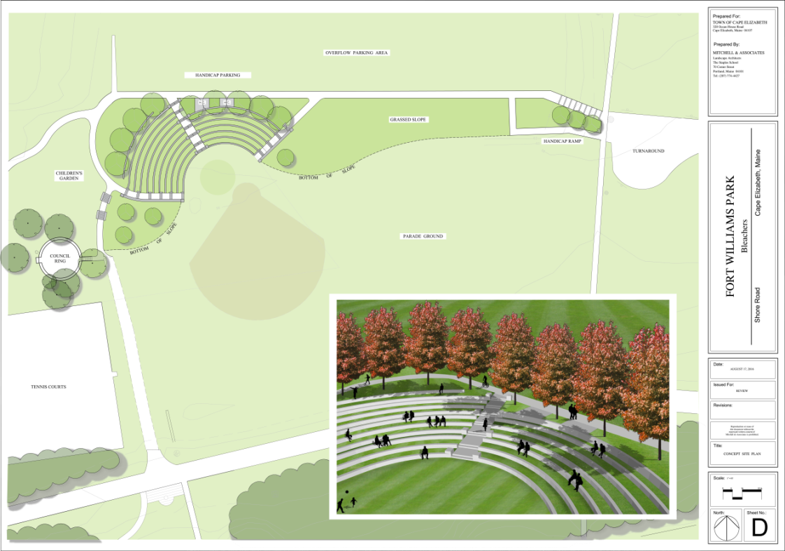Concept plan for amphitheater seating at the Fort Williams Park parade ground. The Fort Williams Park Committee will host a forum on the proposal Wednesday, Aug. 17, 2016 at Town Hall(click for larger image - image courtesy Mitchell & Associates)
The Fort Williams Park Committee will hold a public forum on a concept plan for proposed amphitheater seating at the park's parade ground.
The forum is scheduled for 7 p.m. Wednesday, Aug. 17, 2016, at Town Hall.
The park's budget for 2017 includes $440,000 for engineering and design of amphitheater seating constructed of grass and granite for 350 people. The seats would form a semicircle around the existing ballfield, replacing the concrete bleachers that were removed earlier this spring. [news article]
The funding is based on construction estimates provided by Mitchell & Associates, landscape architects. "It includes consulting services to see the project through Planning Board approval process (if approved by the Town Council) and construction," Public Works Director Robert Malley said. "It does not include ledge removal, a short water line extension and a handicap access ramp. Additional funding may needed for those items," he said.
The parade ground bleacher area has been a primary committee focus for the last two years and is among capital fund priorities. "The proposed amphitheater will provide a unique outdoor space for community gatherings, theatrical and musical performances and school graduations," committee Chairman Mark Russell said in a memo to the Town Council dated April 29, 2016, prior to the council's vote for 2017 budget approval. Some of the granite can be salvaged from Ship Cove, Russell said. The design of the amphitheater seating creates an inviting gateway to the children's garden under construction as part of the Fort Williams Park Foundation arboretum, the memo says.

Forum to gather feedback on pool, fitness center
The Community Services Committee wants your input on the pool and fitness center.
The committee will hold a public forum beginning at 6:30 p.m. Thursday, Aug. 25, 2016 in the High School cafeteria.
Part of the duties of the seven-member committee is to reach out regularly to assess satisfaction with current Community Services programming and to identify unmet needs. Please some share your ideas.
For more information please contact Russell Packett, Community Services director, 207-799-2868

Portland Head Light launches new website
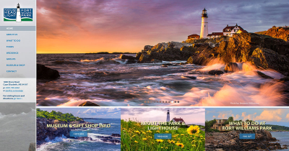
New Portland Head Light and Fort Williams Park website
Portland Head Light has a new website.
The updated, mobile-friendly website for visitors to the lighthouse and surrounding Fort Williams Park was launched July 9, 2016. If features an interactive slide show of photographs, detailed information about the many popular attractions in the park, and secure forms for visitors to ask questions or provide feedback, or to reserve space for a wedding or other event at the park. Tour companies can also request a seasonal parking permit directly from the website.
"There was a need to modernize the Portland Head Light website, so with that thought in mind, it was decided to combine the Portland Head Light and Fort Williams Park into one new site," said Jeanne Gross, director of the Museum at Portland Head Light. The new site also includes information about the new arboretum, and children's garden currently under construction.
Gross, who probably fields more questions from potential park visitors than anyone, said she especially likes the clean, modern, intuitive design of the new website. "We asked photographers to donate the use of their photos and they provided great pictures," she added. Historical background on Fort Williams was provided by Ken Thompson.
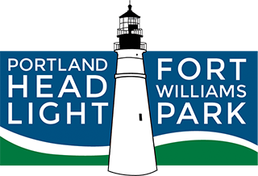
New logo for Portland Head Light and Fort Williams Park website
Visitors planning a trip to Portland Head Light and Fort Williams Park will find on the website answers to some of the most common questions, such as:
- How much does it cost? (The citizens of Cape Elizabeth have decided to keep the park free for all to enjoy.)
- Is the lighthouse tower open to the public? (The tower is not open to the public.)
- Where are the trash barrels? (The park is a carry-in, carry-out facility.)
Slickfish Studios of Portland worked for four months on the design, incorporating new photographs and a new logo that reflects the dual nature of the website. "We designed the logo first, which took about a month, and then spent a considerable amount of time researching photography," said Slickfish owner and lead creative Gordon Holman. Slickfish also designed the site for the Fort Williams Park Foundation.
The work involved some patience, as the gloomy spring of 2016 did not portray the park in its best light, Holman said. "I even went a couple of times to take some pics for use on the site," he said.
The popular webcam photo, providing an updated view of Casco Bay from the lighthouse museum, is accessible from the "About Us" section.

